**IT2120 - Probability and Statistics**

**Name: Kithsilu J.G.A.I**

**IT Number: IT24103050**

**Lab Exercise 9 (Statistical Inference)**

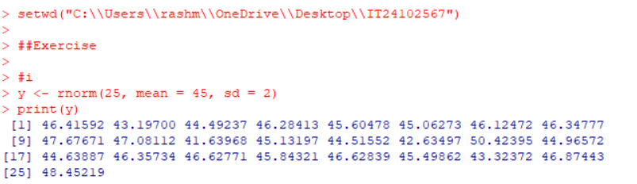**1.**

**2.**